1. Why Do We Need Activation Functions?
Without activation functions, a neural network becomes just a linear model.
Even if you stack 100 layers:
$$W_{3}(W_{2}(W_{1}X))$$
It is still linear.
👉 Activation functions introduce non-linearity, allowing the network to learn:
- Images
- Speech
- Text
- Complex decision boundaries

🧠 2. Types of Activation Functions
We divide them into:
1️⃣ Hidden Layer Activations
2️⃣ Output Layer Activations
Choosing depends on:
- Type of problem
- Output format
- Loss function

📌 3. Hidden Layer Activation Functions
🔹 (A) Sigmoid
$$σ(x)=\frac{1}{1+e^{-x}}$$
Range: (0,1)
✅ Advantages:
- Probabilistic output
- Good for binary outputs
❌ Problems:
- Vanishing gradient
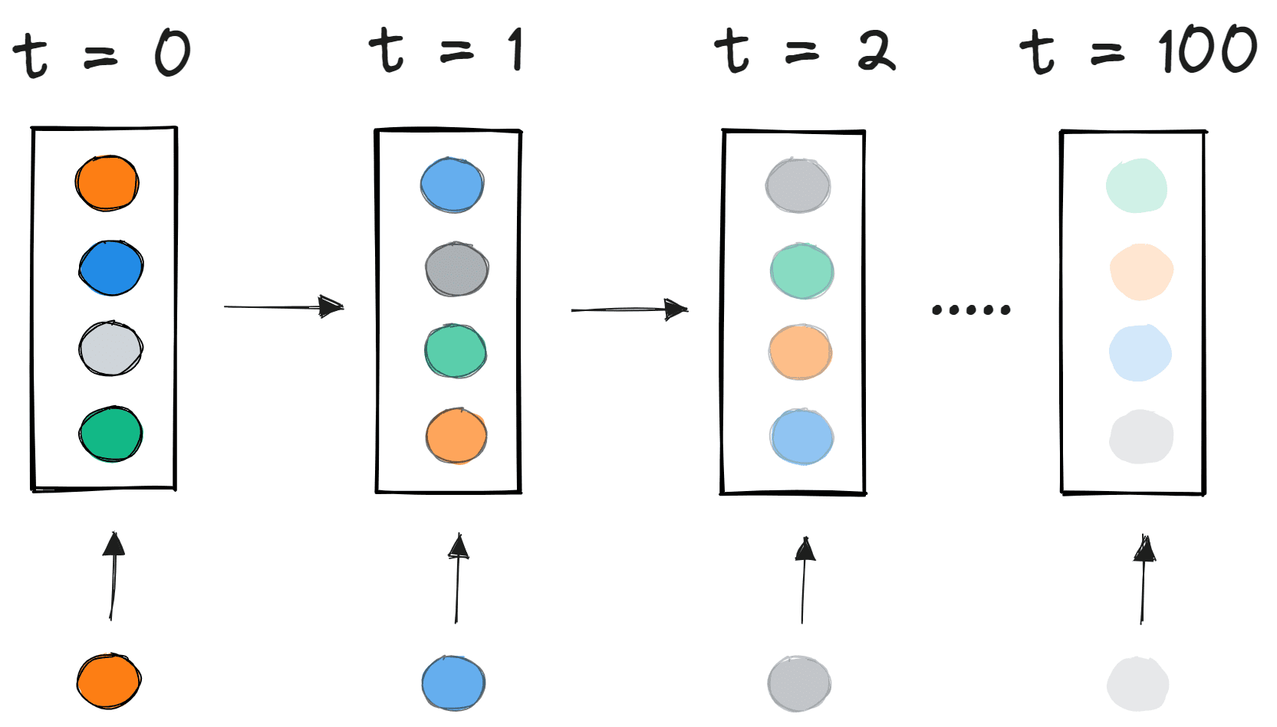
- Not zero-centered
- Slow learning
🚫 Not recommended for hidden layers in deep networks.

🔹 (B) Tanh
$$tanh⁡(x)$$
Range: (-1,1)
✅ Better than sigmoid because:
- Stronger gradients
❌ Still suffers from vanishing gradient.
- Zero centered
What does zero-centered mean?
In deep learning, zero-centered means the values are distributed around zero — meaning they contain both positive and negative values, and their mean is approximately 0.

📌 Simple Example
Suppose you have these values:
- Not zero-centered:
0.2, 0.5, 0.8, 0.9 → all positive → mean > 0
- Zero-centered:
-0.6, -0.2, 0.3, 0.5 → both positive & negative → mean ≈ 0

📊 Why is this important in Neural Networks?
When activations are not zero-centered:
- Gradients during backpropagation will mostly move in the same direction.
- This causes zig-zag updates.
- Training becomes slower.
When activations are zero-centered:
- Gradients update weights more symmetrically.
- Faster convergence.
- –

📉 Visual Understanding
Example: Sigmoid (Not Zero-Centered)
$$y=1/(1+e^{(}-x))$$

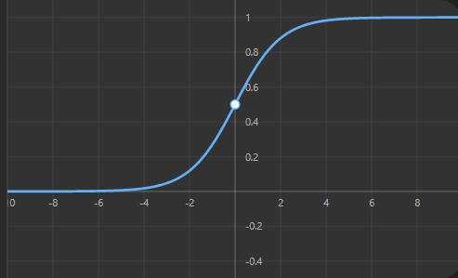
- Output range: 0 to 1
- Always positive
- Not zero-centered ❌

Example: Tanh (Zero-Centered)
$$y=tanh(x)$$

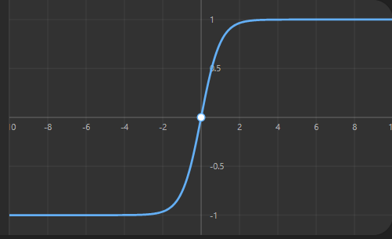
- Output range: -1 to 1
- Balanced around 0
- Zero-centered ✅

🧠 In Deep Learning Context
Activation | Output Range | Zero-Centered?
Sigmoid | (0, 1) | ❌ No
ReLU | (0, ∞) | ❌ No
Tanh | (-1, 1) | ✅ Yes

🔹 (C) ReLU (Most Popular)
$$f(x)=max(0,x)$$
✅ Advantages:
- Computationally efficient
- Solves vanishing gradient (for positive values)
- Sparse activation
- Fast training
❌ Problem:
- Dying ReLU (neurons become permanently 0)
👉 Default choice for hidden layers.

🔹 (D) Leaky ReLU
$$f(x)=max(0.01x,x)$$
✅ Solves dying ReLU
Small gradient for negative values.
👉 Often better than standard ReLU.

🔹 (E) ELU
$$f(x)=x\text{ if }x>0,\text{ else }α(e^{x}-1)$$
✅ Smooth
✅ Better gradient flow
❌ Slightly slower than ReLU

🔹 (F) GELU (Modern Choice)
Used in:
- Transformers
- Large language models
- BERT
Example:
- BERT
✅ Smooth version of ReLU
✅ Strong performance in deep networks

📌 4. Output Layer Activation (VERY IMPORTANT)
This depends strictly on the problem type.

🎯 (1) Binary Classification
Examples:
- Spam detection
- Disease prediction
- Fraud detection
✅ Use:
Sigmoid
Why?
Because output should be probability between 0 and 1.
Loss:
Binary Crossentropy

🎯 (2) Multi-Class Classification (Single Label)
Examples:
- Digit classification
- Image classification
Example dataset:
- MNIST
✅ Use:
Softmax
$$Softmax(x_{i})=\frac{e^{x_{i}}}{∑e^{x_{j}}}$$
Why?
- Outputs probability distribution
- Sum = 1
Loss:
Categorical Crossentropy

🎯 (3) Multi-Label Classification
Example:
Movie can be:
- Action
- Comedy
- Drama (multiple at once)
✅ Use:
Sigmoid (for each output neuron)
NOT softmax.

🎯 (4) Regression
Examples:
- House price prediction
- Temperature prediction
- Sales forecasting
✅ Use:
Linear (No activation)
$$f(x)=x$$
Loss:
MSE / MAE

📌 5. Quick Decision Table (Interview Gold 🔥)
Problem Type | Output Activation
Binary classification | Sigmoid
Multi-class (single label) | Softmax
Multi-label classification | Sigmoid
Regression | Linear
Hidden layers (default) | ReLU
Deep transformer models | GELU

📌 6. Activation Function vs Loss Function Matching
This is important in interviews.
Activation | Compatible Loss
Sigmoid | Binary Crossentropy
Softmax | Categorical Crossentropy
Linear | MSE / MAE
Wrong combination → bad training.

📌 7. How To Choose in Real Projects?
Step 1: Identify problem type
Classification or Regression?
Step 2: Identify output structure
Single label or multiple labels?
Step 3: Choose hidden activation
Default: ReLU
If:
- Deep network → GELU
- Dead neurons issue → Leaky ReLU
- Small shallow network → Tanh

📌 8. Common Interview Questions
❓ Why not use sigmoid in deep networks?
→ Vanishing gradient problem.
❓ Why is ReLU popular?
→ Non-saturating gradient + computational efficiency.
❓ What happens if we use softmax in multi-label?
→ Forces probabilities to sum to 1 → Wrong output.

📌 9. Advanced Considerations (Senior Level)
🔹 Vanishing Gradient
Occurs in:
- Sigmoid
- Tanh
🔹 Exploding Gradient
Handled by:
- ReLU variants
- Gradient clipping
- Proper initialization
🔹 Batch Normalization
Sometimes reduces dependence on activation choice.

📌 10. Modern Best Practices (2026)
- Hidden layers → ReLU or GELU
- CNNs → ReLU
- Transformers → GELU
- Binary → Sigmoid
- Multi-class → Softmax
- Regression → Linear

1️⃣ What Are Gradients?
In neural networks, training happens using:
$$\text{Backpropagation}+\text{Gradient Descent}$$
Gradients tell us:
👉 How much to change each weight
👉 In which direction
If gradients behave badly → training fails.

⚠️ 2️⃣ Vanishing Gradient Problem
🔹 What Is It?
During backpropagation, gradients become very small (close to 0) as they move backward through layers.
As a result:
- Early layers learn extremely slowly
- Deep networks stop improving
- Model accuracy stagnates

🔹 Why Does It Happen?
Backpropagation multiplies gradients layer by layer.
Example:
If derivative ≈ 0.1 and network has 10 layers:
$${0.1}^{10}=0.0000000001$$
That’s almost zero.

🔹 Where It Commonly Occurs?
- Sigmoid activation
- Tanh activation
- Very deep networks
- Recurrent Neural Networks (RNNs)
Example:
- Elman network (early RNN type)

🔹 Why Sigmoid Causes Vanishing?
Sigmoid derivative:
$$σ^{'}(x)=σ(x)(1-σ(x))$$
Max value = 0.25
Most values ≈ very small
So gradients shrink layer after layer.

🔹 Symptoms
- Training loss not decreasing
- Early layers' weights barely update
- Model stuck at poor accuracy

💥 3️⃣ Exploding Gradient Problem
🔹 What Is It?
Gradients become very large during backpropagation.
As a result:
- Weight updates become huge
- Model becomes unstable
- Loss becomes NaN or infinite

🔹 Why Does It Happen?
If derivative > 1 repeatedly:
Example:
$${1.5}^{10}=57.6$$
Gradients grow exponentially.

🔹 Where It Happens?
- Deep networks
- Recurrent Neural Networks
- Poor weight initialization

🔹 Symptoms
- Loss fluctuates wildly
- Loss becomes NaN
- Model diverges
- Sudden accuracy collapse

🔬 4️⃣ Why RNNs Are Highly Affected?
Because they multiply gradients across time steps.
If sequence length = 100:
Gradient multiplied 100 times.
That’s why basic RNNs fail for long sequences.
Solution was introduced in:
- Long Short-Term Memory
- Gated Recurrent Unit
These architectures control gradient flow using gates.

🧮 5️⃣ Mathematical Intuition
During backprop:
$$\frac{∂L}{∂W}=\frac{∂L}{∂a_{n}}⋅\frac{∂a_{n}}{∂a_{n-1}}⋅...⋅\frac{∂a_{1}}{∂W}$$
If each term < 1 → Vanishing
If each term > 1 → Exploding
It’s repeated multiplication.

🛠 6️⃣ How To Fix Vanishing Gradient?
✅ 1. Use ReLU Instead of Sigmoid
ReLU derivative:
- 1 for positive values
- Doesn’t shrink gradient

✅ 2. Better Initialization
- Xavier Initialization
- He Initialization (best for ReLU)
He initialization keeps variance stable across layers.

✅ 3. Batch Normalization
Normalizes activations → stabilizes gradients.

✅ 4. Use Residual Connections
Introduced in:
- ResNet
Residual learning allows gradients to skip layers:
$$y=F(x)+x$$
This helps deep networks (50+ layers) train properly.

✅ 5. Use LSTM / GRU (for sequences)
Solves long-term dependency issues.

🛠 7️⃣ How To Fix Exploding Gradient?
✅ 1. Gradient Clipping (Most Common)
If gradient > threshold → scale it down.
Example:
$$g=\frac{g}{∣∣g∣∣}*threshold$$
Very common in RNN training.

✅ 2. Proper Weight Initialization
Avoid very large initial weights.

✅ 3. Lower Learning Rate
Large learning rate amplifies explosion.

📊 8️⃣ Vanishing vs Exploding (Quick Comparison)
Feature | Vanishing | Exploding
Gradient value | → 0 | → ∞
Effect | Slow learning | Unstable learning
Loss behavior | Stuck | NaN / diverging
Common in | Sigmoid, Tanh | Deep RNNs
Fix | ReLU, ResNet | Gradient clipping

🎯 9️⃣ Interview-Ready Explanation (2 Minute Answer)
“Vanishing and exploding gradients occur due to repeated multiplication of derivatives during backpropagation. If the derivatives are less than 1, gradients shrink exponentially, causing early layers to stop learning — known as vanishing gradient. If derivatives are greater than 1, gradients grow exponentially, leading to unstable weight updates — known as exploding gradient. These problems are common in deep networks and RNNs. Solutions include ReLU activation, proper weight initialization, batch normalization, gradient clipping, and architectures like ResNet and LSTM.”

🚀 10️⃣ Why Modern Deep Learning Doesn’t Suffer Much?
Because of:
- ReLU
- He initialization
- Batch normalization
- Residual connections
- LSTM/GRU
- Transformers (no long gradient chains like RNNs)
Example modern model:
- BERT
Uses:
- GELU activation
- Residual connections
- Layer normalization

💡 Final Intuition
Think of gradient flow like water in pipes:
- Vanishing → Water pressure becomes zero
- Exploding → Pipe bursts
- Residual connections → Add bypass pipeline

Image 1 — Pure Linear Relationship
This is what happens without activation:
$$y=2x+1$$
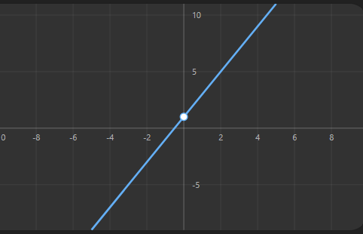
✔ Straight line
✔ Linear relationship
✔ Can only model simple patterns
Even if you stack layers:
$$y=W_{3}(W_{2}(W_{1}x))$$
It still becomes another straight line.
👉 Multiple linear layers = still linear.

🖼️ Image 2 — Slightly More Complex But Still Linear
Example:
$$y=-3x+4$$
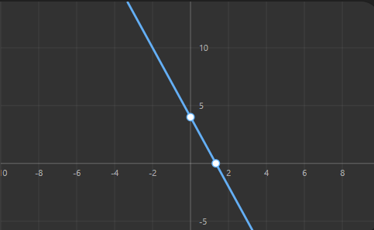
Still a straight line.
No matter how many layers —
Without activation, neural networks collapse into a linear regression model.

🖼️ Image 3 — Introducing Non-Linearity (Activation)
Now let’s apply a nonlinear activation like tanh:
$$y=tanh(x)$$
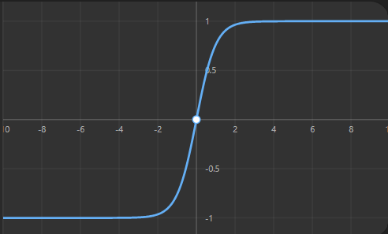
Notice:
✔ It curves
✔ It bends
✔ It is NOT a straight line
This is what gives neural networks power.

🖼️ Image 4 — Complex Nonlinear Function
Now imagine stacking nonlinear layers:
$$y=x^{3}-3x$$
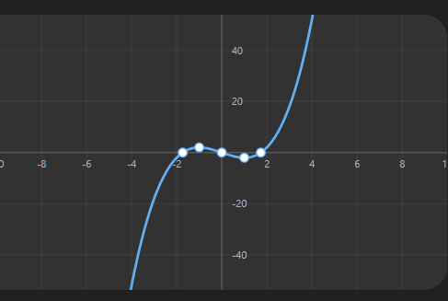
Now the model can:
✔ Bend multiple times
✔ Fit curved data
✔ Learn complex real-world relationships

